Description |  |  | 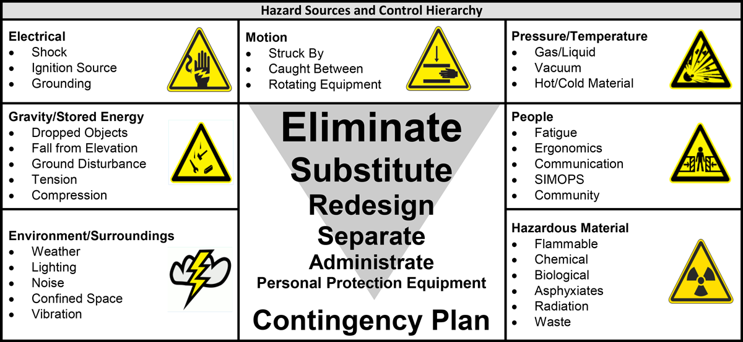
Unique Identifier | Equipment ID:
Vessel Tank Excavation Other:
Space Description:
Purpose for Entry:
Product/Service:

Activities, Hazards, and Controls
Activity or Condition  Describe what it is in or outside the space  that introduces the hazard | Yes | No | Hazard/Consequences  Use the 7 Hazard Sources and prompts to identify the specific hazard and what could happen if exposed | Controls  Use the hierarchy to determine specific, actionable controls which must be implemented to protect against the hazard | Person Assigned
Is there a hazardous atmosphere condition in the space requiring elimination prior to removal of the cover?
(e.g., steam, flush, wash, purge, ventilation)
Is there potential for Liquids or Solids Ingress into the space (from Process or External Source)?
Is there potential for Poisonous Gases, Fumes or Vapor Ingress into the space (from Process or External Source)?
Does the potential for Aromatic Hydrocarbons such as Benzene, Toluene, Ethyl Benzene or Xylene (BTEX) exist in the space? If yes, test for BTEX prior to entry. Reference Industrial Hygiene
Is specialized PPE required to protect entrants from recognized hazards?
Does the Confined Space Configuration have restriction from internal equipment or configuration?
Are there mechanical or moving devices that require isolation prior to entry?
Does the space entry and exit present a hazard? Is secondary entry/exit means available?
Are pedestrian, vehicle, dropped object or other barriers necessary to protect entrants?
Is lighting available to meet the hazard requirements of the space?
Will communication between the entrant and attendant be restricted?
Will equipment with the potential to build static charge be used? (air, liquid, vacuum hoses, fan/air movers)
Will work in or outside the space introduce a hazardous condition? (e.g., hot work, scaffolding, water/abrasive blasting, painting/coating, radiography)
Will oxygen consuming or combustion equipment be used in the space?
Does the space contain or have the potential to contain asbestos?
Are there excessive noise levels in the confined space that would hinder communication with entrants? If so, has alternate means of communication been established such as visual contact and hand signals?
Will the attendant be required to monitor more than one space?
(define how they will monitor and respond to an emergency)
If electrical or pressurized lines entering the space at the same access/egress point, has a saddle or other form of protection been identified?
Does the space require scaffolding or other means to work at heights while performing duties?
Was the space tested for N.O.R.M? If present, reference Industrial Hygiene hazardous material limits and requirements.
Does the potential for Mercury or Mercury vapor exist in the space? If yes, test for Mercury vapor prior to entry. Reference Industrial Hygiene hazardous material limits and requirements.
Have test criteria been established for all safety equipment prior to work commencing at the beginning of each day?

The following equipment/personnel are to be on standby during confined space work.

Emergency Rescue Plan
Rescue Equipment |  | Rescue Personnel | Method of Contact
First Aid Kit | SCBA for rescue | 1. | Public Address System
Medical Oxygen Kit | Tripod/Lifting Frame | 2. | Radio Channel:
Radio | “No Entry” means of retrieval | 3. | Phone Number:
Stretcher | Other ______________________ | 4. | Other:

Primary and Secondary Rescue Procedure (attach diagrams and drawings if needed)
Warning: NO one is to enter a Confined Space for rescue without Positive Pressure Breathing Air
1.
2.
3.
4.
5.
6.
7.
8.
9.
10.
11.

